SIMATS ENGINEERING (SAVEETHA SCHOOL OF ENGINEERING)
Department of Computer Science and Engineering
CO3 ASSESSMENT TOOL 1 – Git & Docker Technical Assignment

Course Code: | CSA10 / CSA1063 | Course Title: | Software Engineering
CO Assessed: | CO3 | Assessment: | Assessment Tool 1 – Git & Docker Technical Assignment
Weightage: | 20% | Total Marks: | 25
CO3 Statement: | Build full-stack applications with an emphasis on containerization, version control, and collaborative development
Student Name: | K.Prathiba | Reg. No.: | 192421163
Date: | 12/08/2026 | Duration: | 60 minutes

Code of Conduct
I _____ K.Prathiba_(192421163)____ (Name / Reg No) certify that this submission is my original work and that I have adhered to the guidelines specified for this assessment. I understand that any violation of academic integrity rules will result in disciplinary action.
Signature of the Student: K.Prathiba
Annexure A – Git & Docker Technical Assignment
Instructions to Students:
Each student has been assigned an individual problem statement. Based on the assigned problem statement, prepare a Git & Docker Technical Assignment by applying version control and containerization concepts. Your report should include appropriate diagrams, screenshots, commands, and explanations wherever applicable.

Assignment Questions
- Problem Analysis
1.1 Problem Statement
- Managing personal finances is an important activity for individuals because it helps them control their income, expenses, savings, and financial goals. However, many people find it difficult to maintain their financial records regularly. Expenses may be recorded manually in notebooks, spreadsheets, or different applications, making it difficult to obtain a complete view of their financial condition.
- Traditional budgeting methods mainly depend on manual calculations. Users have to enter expenses, categorize them, calculate totals, compare them with budgets, and determine whether their spending is under control. This process can be time-consuming and may result in errors.
- The AI-Based Personal Finance and Budget Planning System is proposed to solve these problems by providing a centralized platform for managing personal financial information. The system allows users to record income and expenses, categorize transactions, create budgets, monitor spending, analyze financial patterns, and receive AI-assisted recommendations.
- The AI component analyzes the user's financial information and provides personalized suggestions. For example, if a user spends a large percentage of their income on entertainment or food, the system can identify this pattern and suggest an appropriate reduction in that category.
- The proposed system is intended to act as a financial planning and decision-support system. The recommendations provided by the AI are suggestions, and the user remains responsible for making the final financial decisions.

1.2 Project Objectives
The major objectives of the project are:
- To provide a simple system for recording income and expenses.
- To categorize financial transactions automatically or manually.
- To allow users to create monthly budgets.
- To monitor spending against the allocated budget.
- To provide graphical financial analytics.
- To identify spending patterns.
- To generate personalized AI-based budgeting recommendations.
- To provide alerts when users approach their budget limits.
- To securely store user financial information.
- To use Git for version control and collaborative development.
- To use Docker for application containerization.
- To improve application portability and deployment consistency.

1.3 Functional Requirements

Requirement | Description
User Registration | Users can create an account.
User Login | Users can securely log into the system.
Income Management | Users can record income sources.
Expense Management | Users can add and manage expenses.
Expense Categorization | Expenses can be categorized.
Budget Creation | Users can create category-wise budgets.
Budget Monitoring | System compares spending with budgets.
Financial Dashboard | Displays income, expenses and savings.
Financial Analytics | Provides spending trends and statistics.
AI Recommendation | Generates personalized financial suggestions.
Notifications | Provides budget alerts.
Database Management | Stores user and financial information.

1.4 Non-Functional Requirements

Usability
The system should have a simple and understandable user interface.

Security
User credentials and financial information should be protected using authentication and authorization mechanisms.

Performance
The system should provide dashboard and transaction information within an acceptable response time.

Reliability
The application should continue functioning correctly after normal container restarts.

Maintainability
The source code should be modular and organized so that developers can easily modify it.

Portability
The application should run consistently on different systems using Docker.

Scalability
The architecture should allow additional application instances and services to be added in the future.

1.5 Expected Outcomes
The expected outcome is a full-stack personal finance application that allows a user to:
- Register and log in.
- Record income.
- Record expenses.
- Categorize transactions.
- Create monthly budgets.
- Monitor budget utilization.
- View financial analytics.
- Receive AI-based recommendations.
- Receive budget alerts.
The project should also contain a Git repository, branching strategy, meaningful commits, Dockerfile, Docker Compose configuration, and deployment/testing evidence.

- Project Structure Design
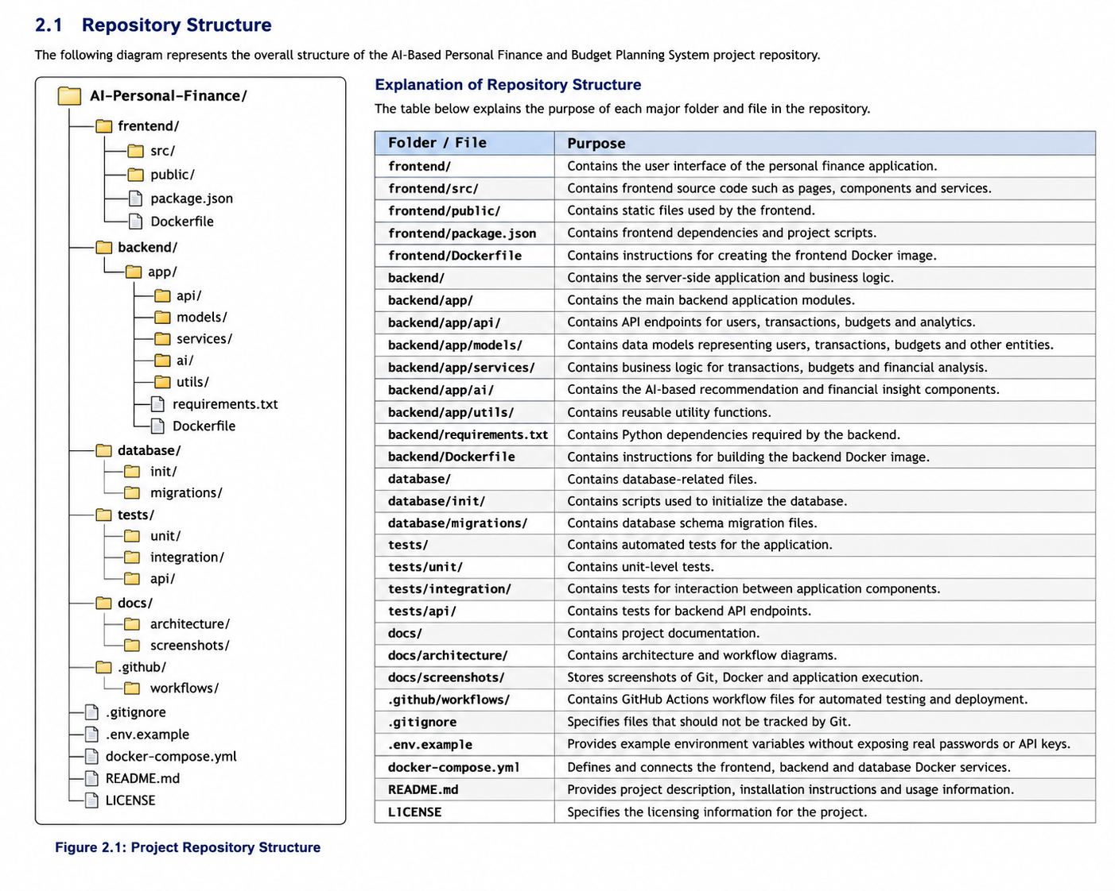

2.2 Folder Description frontend
Contains the user interface of the personal finance application.
It includes:
- Login page
- Registration page
- Dashboard
- Transaction forms
- Budget management
- Analytics charts
- AI recommendation display

backend/
Contains the main application logic and API services.
It handles:
- Authentication
- Transactions
- Budget calculations
- Analytics
- AI recommendations
- Notifications

database/
Contains database initialization scripts and migration files.

tests/
Contains automated tests.
The test structure includes:
- Unit tests
- Integration tests
- API tests

docs/
Contains architecture diagrams, documentation and screenshots.

.github/
Can contain CI/CD workflow files for automated testing and building.

.gitignore
Specifies files that should not be committed to Git.

docker-compose.yml
Defines the different Docker services required by the application.

README.md
Provides project information, installation instructions and usage instructions.
- Git Repository Initialization

3.1 Introduction
Git is a distributed version control system used to manage and track changes in the source code of the AI-Based Personal Finance and Budget Planning System. It helps maintain different versions of the project and provides a systematic way to manage source code, configuration files, documentation, and Docker files.

3.2 Repository Creation
The Git repository is created to store and manage all project-related files in a centralized version-controlled environment. The repository contains the frontend, backend, AI module, database configuration, testing files, Docker files, and project documentation.
The repository can be initialized using:
mkdir ai-personal-finance
cd ai-personal-finance
git init
The git init command creates a hidden .git directory that stores Git configuration, commit information, branch information, and version history.

3.3 Project Repository Structure
The proposed repository structure is:
ai-personal-finance/
│
├── frontend/
├── backend/
├── ai_module/
├── database/
├── tests/
├── docs/
├── .gitignore
├── README.md
├── requirements.txt
├── Dockerfile
└── docker-compose.yml
Each folder has a specific purpose:
- frontend/ – Contains the user interface of the application.
- backend/ – Contains server-side application logic and APIs.
- ai_module/ – Contains AI-based financial analysis and recommendation logic.
- database/ – Contains database-related configuration and scripts.
- tests/ – Contains unit and integration testing files.
- docs/ – Contains project documentation and diagrams.
- .gitignore – Specifies files that should not be tracked by Git.
- README.md – Provides project information and execution instructions.
- requirements.txt – Contains required Python dependencies.
- Dockerfile – Defines the application container image.
- docker-compose.yml – Defines and manages multiple Docker services.

3.4 Creating the Initial Repository
After creating the project files, they are added to the Git staging area:
git add .
The initial project version is then committed:
git commit -m "Initial project setup"
The git add command stages the project files, while git commit permanently records the changes in the Git repository.

3.6 .gitignore File
The .gitignore file prevents unnecessary and sensitive files from being included in the repository.
Example:
__pycache__/
*.pyc
.env
venv/
node_modules/
*.log
The .env file is particularly important because it may contain database passwords, API keys, or other configuration information.

3.7 README File
The README.md file provides basic information about the project. It can include:
- Project title
- Project objectives
- Technologies used
- Installation instructions
- Git commands
- Docker commands
- Testing procedure
- Application usage instructions

3.8 Repository Initialization Workflow
Create Project
↓
Create Repository Folder
↓
git init
↓
Create Project Files
↓
Create .gitignore
↓
git add .
↓
git commit
↓
Connect Remote Repository
↓
git push

3.9 Advantages of Git Repository Initialization
Git repository initialization provides the following advantages:
- Maintains complete project history.
- Tracks modifications made to source files.
- Supports multiple development branches.
- Allows previous versions to be restored.
- Supports collaborative development.
- Provides a foundation for CI/CD integration.
- Helps maintain the Docker and application configuration files systematically.

- Git Branching Strategy

4.1 Introduction
Git branching is used to develop different features independently without directly modifying the stable version of the application.

4.2 Main Branch
The main branch contains the stable and tested version of the project.

4.3 Development Branch
The development branch contains the latest integrated development version.
git checkout -b development

4.6 Hotfix Branch
A hotfix branch is used to correct critical problems in the production version.
git checkout main
git checkout -b hotfix/security-fix

4.7 Branching Workflow
MAIN
↑
│
RELEASE/v1.0
↑
│
DEVELOPMENT
/ | \
↓ ↓ ↓
LOGIN BUDGET AI
FEATURE FEATURE FEATURE
\ | /
\ | /
DEVELOPMENT
│
↓
MAIN

4.8 Justification
This branching strategy is suitable because the project contains multiple independent modules. Developers can develop and test each feature separately before integrating it into the development branch. The main branch remains stable and contains only tested code.

- Version Control Workflow

5.1 Introduction
Version control is used to track and manage changes made to the AI-Based Personal Finance and Budget Planning System. Git provides a systematic workflow for developing features, testing changes, maintaining versions, and integrating completed modules.
The project follows a feature-based Git workflow where individual functionalities are developed in separate branches and merged into the development branch after testing.

5.2 Git Workflow
The workflow followed in the project is:
Create / Pull Repository
↓
Create Feature Branch
↓
Develop Feature
↓
Test Feature
↓
git add
↓
git commit
↓
git push
↓
Review
↓
Merge into Development
↓
Final Testing
↓
Merge into Main

5.4 Staging and Committing Changes
After implementing a feature, the changes are checked using:
git status
The files are then added to the staging area:
git add .
A meaningful commit is created:
git commit -m "Implement monthly budget planning"
Meaningful commit messages make the project history easier to understand.

5.5 Pushing Changes
The feature branch is uploaded to the remote repository using:
git push -u origin feature/budget-planning
After testing and review, it can be merged into the development branch:
git checkout development
git merge feature/budget-planning

5.8 Importance
The version control workflow provides:
- Organized development.
- Safe feature implementation.
- Easy collaboration.
- Version tracking.
- Error recovery.
- Controlled merging.
- Better project maintenance.

- Commit History Analysis

6.1 Introduction
Git commit history provides a chronological record of changes made to the project. Each commit represents a logical change in the development process.
The history can be viewed using:
git log --oneline

6.4 Importance of Commit History
Commit history helps developers:
- Identify when a feature was introduced.
- Track modifications.
- Find the source of bugs.
- Restore previous versions.
- Understand project development.
- Maintain the application efficiently.
Therefore, a meaningful commit history improves the maintainability and reliability of the project.

- Docker Environment Design

7.1 Introduction
The AI-Based Personal Finance and Budget Planning System contains different application components. Docker allows these components to run in isolated and consistent environments.

7.2 Need for Docker
Without containerization, the application may behave differently on different systems because of differences in:
- Python versions.
- Library versions.
- Database versions.
Docker solves this problem by providing a consistent execution environment.

7.4 Application Components

Frontend Container
Provides the user interface for:
- Login.
- Income entry.
- Expense entry.

Backend Container
Handles:
- User authentication.
- Expense processing.
- Budget calculation.

AI Module
Analyzes user spending patterns and generates personalized financial recommendations.

Database Container
Stores:
- User information.
- Income details.
- Expense records.
- Budget information.
- Financial analysis results.

7.5 Docker Network
The containers communicate through a Docker network.
Frontend
│
↓
Backend
├──────→ AI Module
│
└──────→ Database
This provides communication between services without requiring manual network configuration.

- Dockerfile Development

8.1 Introduction
A Dockerfile is a text file containing instructions required to build a Docker image. The Dockerfile defines the base environment, application dependencies, source code, port, and startup command.

8.2 Dockerfile
The backend application can be containerized using:
FROM python:3.11-slim

WORKDIR /app

COPY requirements.txt .

RUN pip install --no-cache-dir -r requirements.txt

COPY . .

EXPOSE 8000

CMD ["python", "main.py"]

8.3 Explanation of Dockerfile Instructions

FROM
FROM python:3.11-slim
Specifies Python as the base runtime environment.

WORKDIR
WORKDIR /app
Creates and sets /app as the working directory.

COPY
COPY requirements.txt .
Copies the dependency file into the container.

RUN
RUN pip install --no-cache-dir -r requirements.txt
Installs the required Python packages.

COPY Application Files
COPY . .
Copies the application source code into the container.

EXPOSE
EXPOSE 8000
Specifies the port used by the backend application.

CMD
CMD ["python", "main.py"]
Defines the command used to start the application.

8.4 Building the Docker Image
The image can be created using:
docker build -t personal-finance-app .

8.5 Running the Container
docker run -p 8000:8000 personal-finance-app
The application is then available through the mapped port.

8.6 Advantages
The Dockerfile ensures that:
- Dependencies are installed consistently.
- Application configuration is repeatable.
- Deployment becomes easier.
- The application can run on different machines.
- Environment-related errors are reduced.

- Docker Compose Design

9.1 Introduction
Docker Compose is used to define and manage multiple containers as a single application. It is suitable for this project because the backend and database need to operate together.

9.3 Backend Service
The backend service builds the application using the Dockerfile.
backend:
build: ./backend
Port 8000 is mapped between the host machine and the container.

9.4 Database Service
PostgreSQL is used as the database service.
database:
image: postgres:16
The database stores financial records and user information.

9.5 Environment Variables
Environment variables provide configuration information such as:
POSTGRES_USER
POSTGRES_PASSWORD
POSTGRES_DB
DATABASE_URL
In an actual deployment, sensitive values should preferably be stored in an .env file or secure secret-management system.

9.6 Volumes
The following volume provides persistent database storage:
volumes:
finance_data:
The data remains available even if the database container is recreated.

9.7 Dependencies
The backend depends on the database:
depends_on:
- database
This establishes the service dependency required by the application.

9.8 Starting the Services
docker compose up --build
To run in the background:
docker compose up -d --build
To stop the services:
docker compose down

- Container Deployment and Testing

10. Container Deployment and Testing

10.1 Introduction
After developing the Dockerfile and Docker Compose configuration, the application is deployed using Docker containers. Testing verifies that the application, database, and required services operate correctly.

10.2 Building Containers
The application is built using:
docker compose build
This creates the required Docker images.

10.3 Starting Containers
docker compose up -d
The services are started in detached mode.

10.4 Checking Running Containers
The following command verifies the running containers:
docker ps
Expected containers include:
finance_backend
finance_database

10.5 Checking Logs
Application logs can be viewed using:
docker compose logs
Backend-specific logs can be checked using:
docker compose logs backend
Logs help identify configuration, application, and database connection problems.

10.7 Deployment Verification
The final deployment should demonstrate:
Docker Compose
↓
Backend Container
↓
Database Container
↓
Application Running
↓
Functional Testing
↓
Successful Result

10.8 Screenshots Required
The report should include screenshots of:
- Git repository.
- Git branches.
- Commit history.
- Dockerfile.
- Docker Compose file.
- docker compose build.
- docker compose up.
- docker ps.
- Docker logs.
- Running application.
These screenshots provide practical evidence for the implementation.

- Benefits of Git and Docker

11. Benefits of Git and Docker

11.1 Benefits of Git
Git provides effective version control for the project.

Error Recovery
Previous stable versions can be restored when a newly introduced change causes an error.

11.2 Benefits of Docker

Portability
The application can run consistently on different systems.

Environment Consistency
Application dependencies and runtime environments are standardized.

Isolation
The backend and database operate in separate containers.

Easy Deployment
The application can be started using a small number of Docker commands.

Scalability
Individual services can be scaled according to system requirements.

11.3 Combined Benefits
Git and Docker complement each other.
GIT
│
Source Management
│
↓
Source Code
│
↓
DOCKER
│
Containerization
│
↓
Deployment

- Challenges and Improvements

12. Challenges and Improvements

12.1.1 Git Merge Conflicts
Conflicts can occur when different branches modify the same section of a file.
Solution: Regularly synchronize branches and resolve conflicts before merging.

12.1.2 Database Connectivity
The backend may initially fail to connect to PostgreSQL if an incorrect hostname is used.
Inside Docker Compose, the database service name should be used as the hostname:
database
instead of:
localhost

Database passwords and API keys should not be committed to Git.
Solution: Use .env files and include them in .gitignore.

12.2.6 AI Enhancement
The AI module can be improved to provide:
- Personalized spending recommendations.
- Future expense prediction.
- Unusual spending detection.
- Automatic expense categorization.
- Financial goal prediction.
- Smart monthly budget suggestions.

12.4 Conclusion
Git and Docker provide a reliable development and deployment environment for the AI-Based Personal Finance and Budget Planning System.
Git manages source-code versions, branches, commits, collaboration, and project history. Docker provides a consistent environment for running the application and its dependencies. Docker Compose simplifies the management of multiple services such as the backend and database.

Expected Deliverables
- Technical report (10 pages)
- Git repository with complete commit history
- Source code of the assigned project
- Dockerfile
- Docker Compose file (docker-compose.yml)
- Screenshots of Git operations and Docker execution
- Architecture and workflow diagrams

Rubrics for Calculation
Evaluation Criteria | Excellent (4 Marks) | Good (3 Marks) | Satisfactory (2 Marks) | Needs Improvement (1 Mark)
Problem Analysis & Project Design(20%) | Clearly explains the problem statement, objectives, requirements, expected outcomes, and well-organized project structure with proper justification. | Good analysis and project structure with minor omissions. | Basic analysis and repository structure with limited justification. | Incomplete or unclear analysis and project organization.
Git Repository & Branching Strategy(20%) | Repository initialized correctly with appropriate branching strategy, clear workflow, and proper repository organization. | Repository and branching strategy are mostly correct. | Basic Git setup with limited branching implementation. | Incorrect or incomplete Git repository and branching strategy.
Version Control Workflow & Commit History(10%) | Demonstrates meaningful commits, branching, merging, synchronization, conflict resolution, and professional commit messages with clear history. | Most Git operations demonstrated correctly with good commit history. | Limited Git workflow and commit practices. | Poor workflow and inadequate commit history.
Docker Implementation(20%) | Well-designed Docker environment, Dockerfile, and Docker Compose configuration with clear explanation of services, networking, volumes, and dependencies. | Functional Docker implementation with minor issues. | Basic Docker implementation with limited explanation. | Incomplete or incorrect Docker implementation.
Deployment, Testing & Results(15%) | Application successfully deployed and tested with appropriate screenshots and evidence of successful execution. | Deployment completed with minor issues. | Partial deployment and testing demonstrated. | Deployment unsuccessful or insufficient evidence.
Documentation, Challenges & Future Enhancements(15%) | Professional report (10–15 pages) with diagrams, screenshots, references, discussion of benefits, challenges, and future improvements. | Good documentation with minor omissions. | Basic documentation with limited discussion. | Poor documentation and insufficient analysis.

Criteria | Mark
System Requirement Analysis (30%) | /5
Selection of Software Architecture (25%) | /5
Architecture Diagram and Component Design (20%) | /5
Component Interaction and Quality Attribute Analysis (15%) | /5
Architectural Justification and Technical Presentation (10%) | /5
TOTAL | /25

